Eventi
Use Case Specification

Submitted to:

Asst. Prof. Ma. Rowena C. Solamo
Faculty Member
Department of Computer Science
College of Engineering
University of the Philippines, Diliman

Submitted by:
Dimaano, Aaron Diego I.
Lopez, Matthew S.
Torres, Jacob Angelo V.

In partial fulfillment of academic requirements
for the course
CS 191 Software Engineering I
of the
1st Semester, AY 2015-2016
Unique Reference:
The documents are stored in https://github.com/Tom-2013-06417/CS191-192_Event_Sharing/tree/master/02-Requirements%20Engineering.
Link to this document:

Document Purpose:
The purpose of this document is to exhaust the step-by-step process of the Use Cases in every scenario possible.

Target Audience:
To our project client and adviser, our fellow 191 classmates, and our future selves when they need to refer back to this document.

Revision Control:

Revision Date | Person Responsible | Version  Number | Modification
09/18/15 | Dimaano, Diego  Lopez, Matthew  Torres, Jacob | 1.0 | Initial Document

Use-Case Name: Manage accounts

Description: By controlling who stays within the site’s community, administrators can culture a healthy environment.

Preconditions: There is an internet connection to the Eventi server and a device with browsing capabilities. An Administrator is currently logged in.

Flow of Events:

Scenario Name | Description
Scenario 1 (Basic Flow)  Administrator terminates an account / organization that has been reported  numerous times before | 1. Administrator opens the Administrative Panel  2. Administrator moves to terminate an account or organization due to their content  3. If the accounts or organizations in mention have reached the threshold amount of reports required for termination, then the account is successfully terminated
Scenario 2  Administrator terminates an account / organization that hasn’t been reported  the required amount of times | 1. Administrator opens the Administrative Panel  2. Administrator moves to terminate an account or organization due to their content  3. If the accounts or organizations in mention have not reached the threshold amount of reports required for termination, then the Administrator may opt to override the threshold requirement and proceed with manually terminating the account/organization  4. System asks the Administrator for the reason why the account/organization is being terminated  5. The Administrator provides verification for overriding the threshold requirement  6. The account/organization has been terminated successfully
Scenario 3  Administrator cancels the process | 1. Administrator opens the Administrative Panel  2. Administrator moves to terminate an account or organization due to their content  3. If the accounts or organizations in mention have not reached the threshold amount of reports required for termination, then the Administrator may opt to override the threshold requirement and proceed with manually terminating the account/organization  4. The Administrator did not continue with the termination process

Activity Diagram of the Flow of Events:

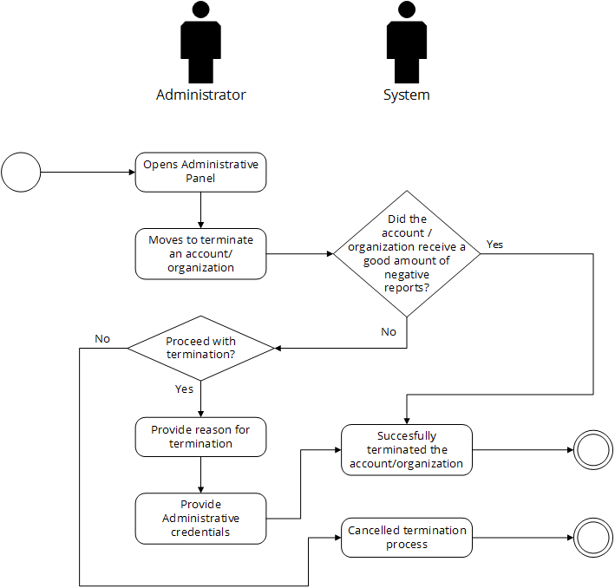

Post-conditions: Successful: The Eventi homepage has successfully loaded and the events are shown.
Failed: The website did not load.

Special Requirements: NONE

